George Whiting

developer  for Chalets and Caviar

Chalets and caviar website instructions

**Chalets and Caviar Website Instructions**

This instruction document will go through in detail how you can edit, add to and maintain the website. I will split the instructions into three key sections in which you can refer to for a quick reference on how to perform specific tasks. These instructions will allow you to alter and add new chalet listings on your website.

**Accessing the website in order to make changes.**

In order to make changes to your website you should go to this link http://chaletsandcaviarrealestate.themecloud.website/wp-login.php

**You should then see this screen, or something similar**.

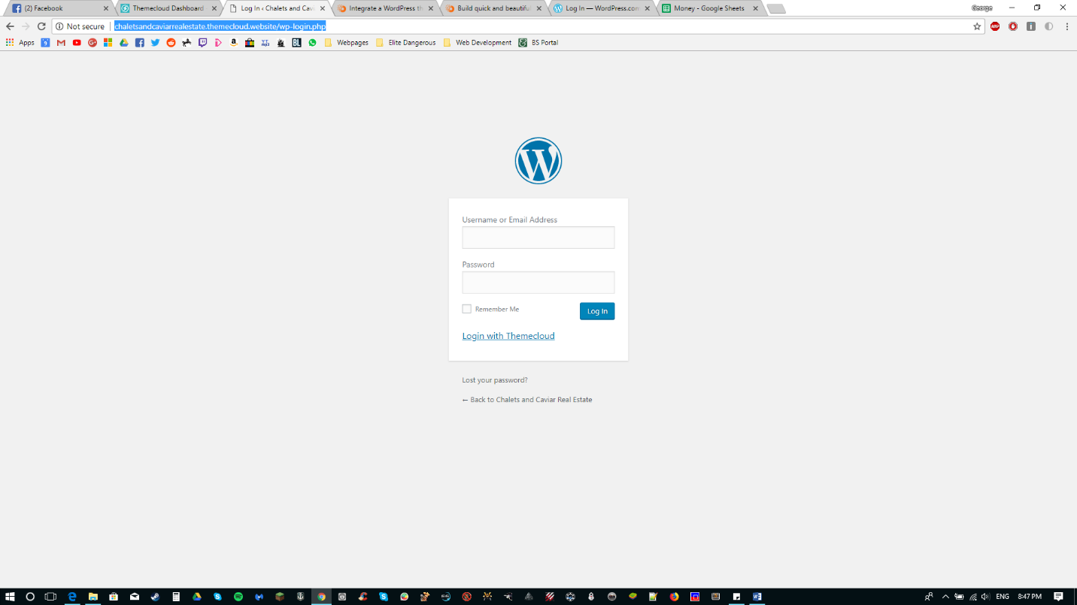

I have made 3 accounts for your use as per requested. An administrator account for the Agency Director and two Editor Accounts for two of your employees.

**I will now show you how to access your accounts on the next page.**

|  |  |  |
| --- | --- | --- |
| Account | Email | Password |
| Agency Director | [gmw_1994@live.co.uk](mailto:gmw_1994@live.co.uk) | chaletsandcaviar |
| Agency Employee 1 | [gw1994m@yahoo.co.uk](mailto:gw1994m@yahoo.co.uk) | chaletsandcaviar |
| Agency Employee 2 | gmw_94@yahoo.co.uk | chaletsandcaviar |

Simply Log in with your specific account credentials. **Please see below for account details.**

Please note that emails are currently temporary and I encourage you to update them to your own and of course the password!

Please note that only the Agency Director and the Developer (Myself) are able to make administrative (Visual) changes to the website. The two employee accounts are editor only accounts. You will be able to add/edit and remove chalet listings with all 3 accounts.

**Section One –** Editing Chalet Listings.

Here I will show you how to add/edit and remove chalet listings on your website. Although you have 3 separate accounts the process is exactly the same across all 3, so I will show you how using the Agency Employee 1 account.

**Accessing the Dashboard**

In order to make any changes to the pages within the website you will need to use your dashboard. **So go ahead and click the highlighted button below:**

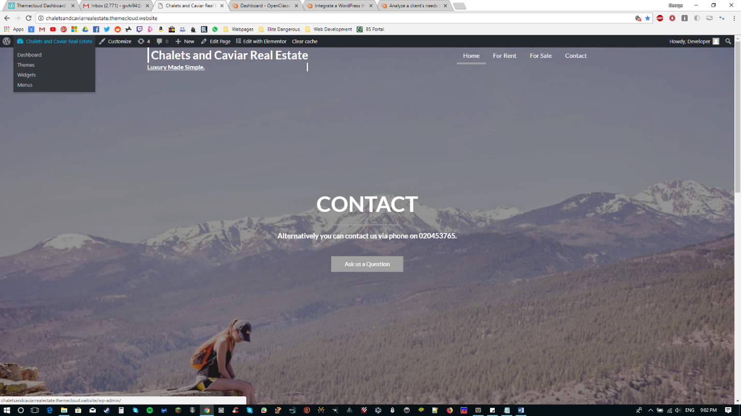

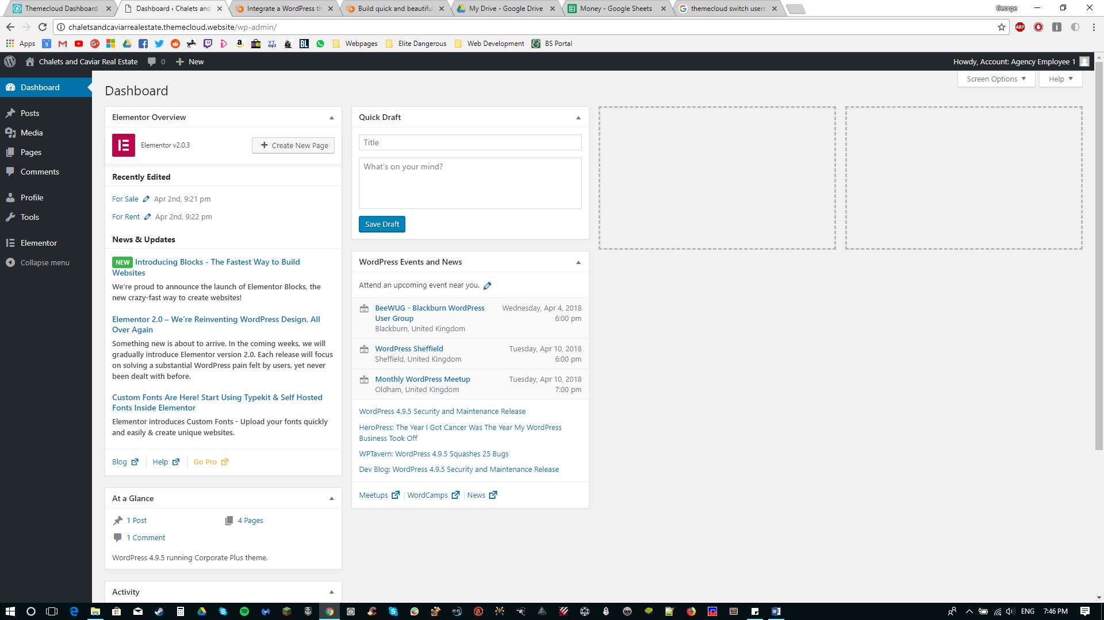**This will then give you this screen:**

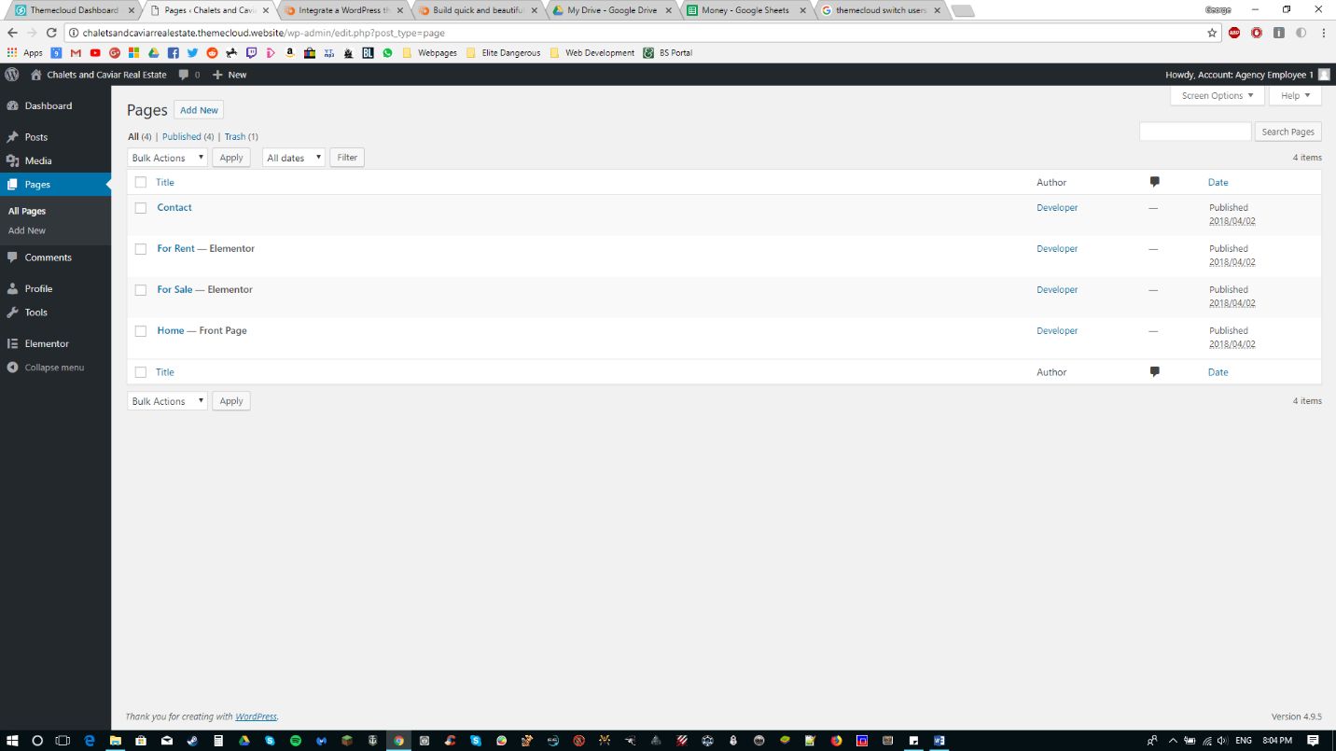We are concerned with the sidebar at the moment, so go ahead and click on pages and you will **see this screen below:**

For this example I will edit the ‘For Rent’ page, keep in mind that the process I will show you is exactly the same for the ‘For Sale’ page. So go ahead and click on the ‘For Rent’ or ‘For Sale’ page.

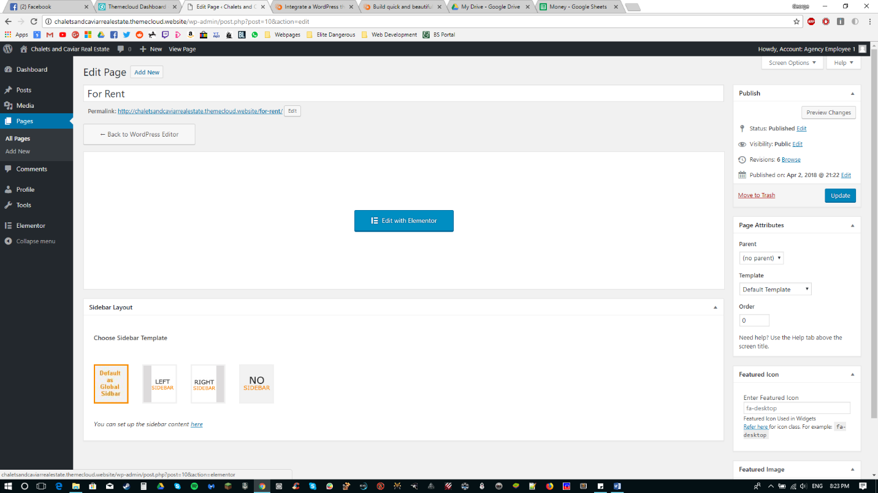**You will then be greeted with this screen below:**

Click on the blue ‘Edit with Elementor’ button, Elementor is a plugin used for easy editing of the web pages, but don’t concern yourself with that too much.

**The Instructions continue on the next page.**

**After clicking this button you will then see this page:**

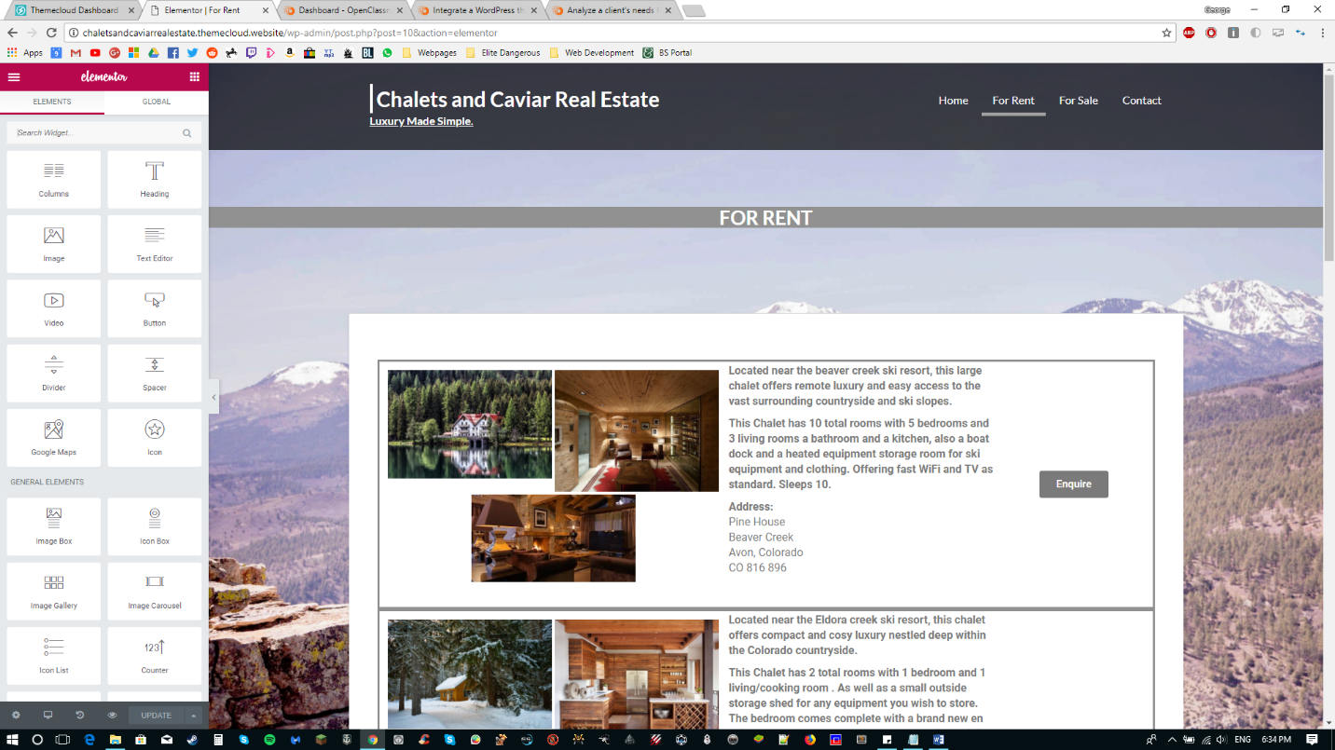

As you can see the page is split into 3 columns, an image column a description column and a button column. Editing the elements within the columns is fairly straightforward.

Also note the sidebar on the left, we will be using this.

To edit the text, double click on the text field and you are then able to type and delete as you wish.

To change the images click on the image you wish to change, you will then see on the far left side the ability to change your image, **see below:**

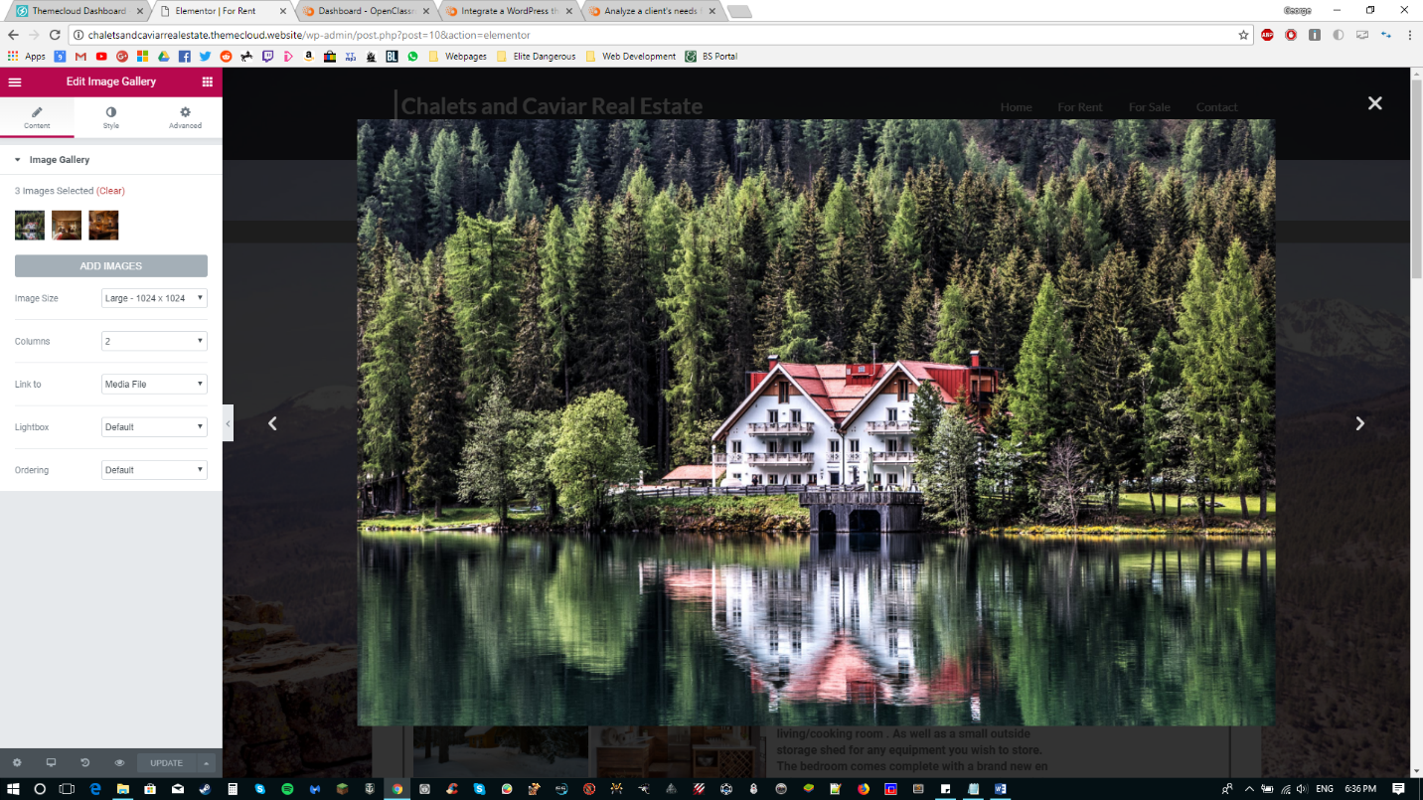

Click this and you are then able to choose an image of your choice, ensure that the image is **saved locally on your PC.**

Currently the website displays 3 chalet images, you are able to display more if you wish or less if you wish, the choice is yours.

**Section Two –** Adding additional Chalet Listings.

This process is very similar to the above instructions.

Firstly scroll to the bottom of the page and click **‘Add new Section’**

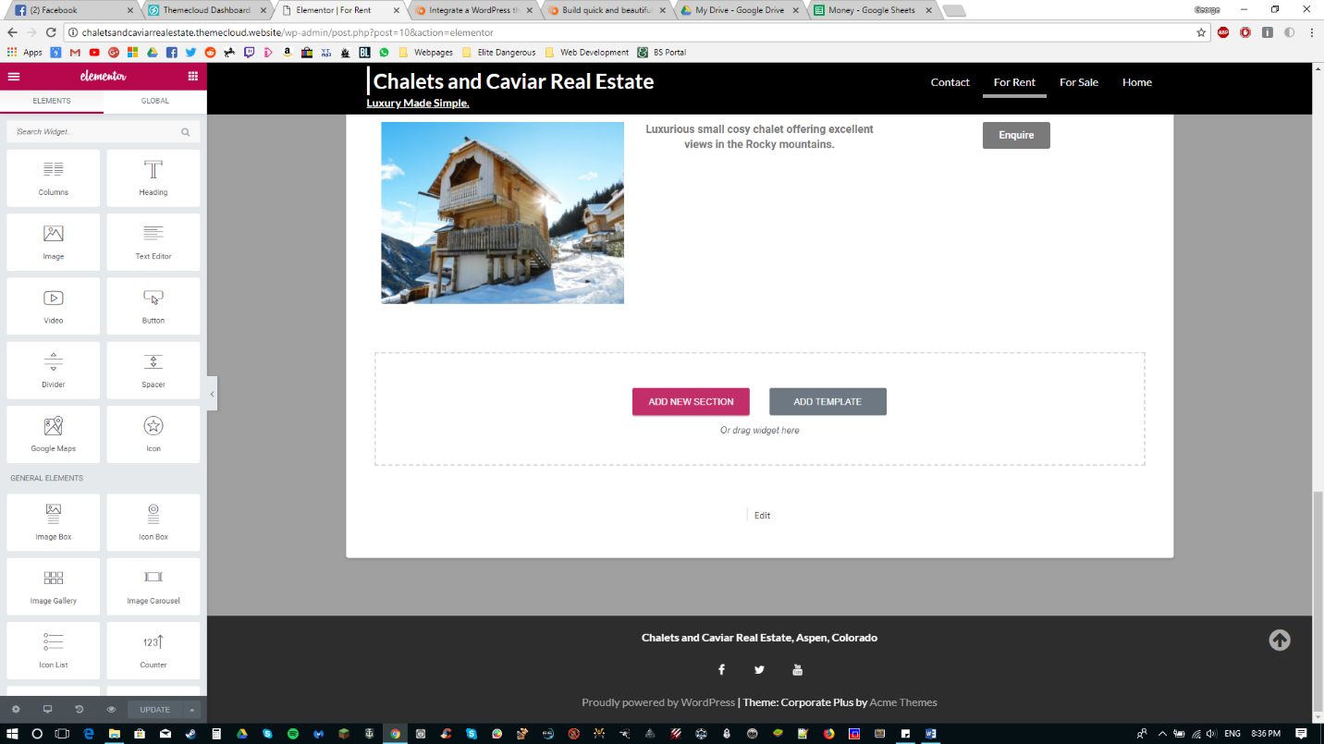

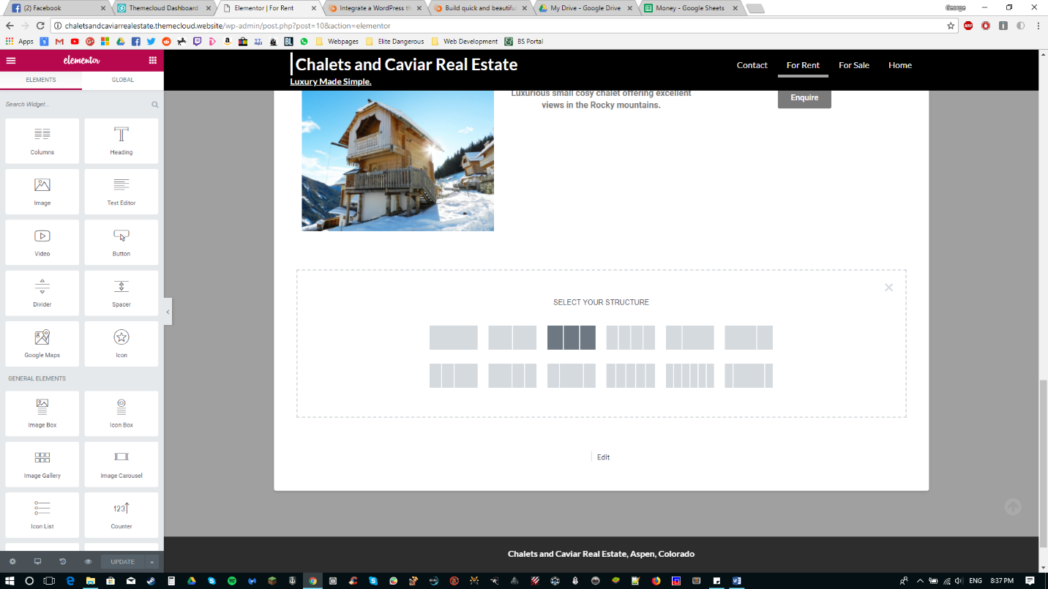**Then click the 3 column structure**:

Then using the **left panel**, drag and drop the relevant elements into the corresponding columns

(Image gallery in the left column, text editor in the middle and button on the right)

Then simply repeat the process in section one above to edit.

**Elements you will need**:

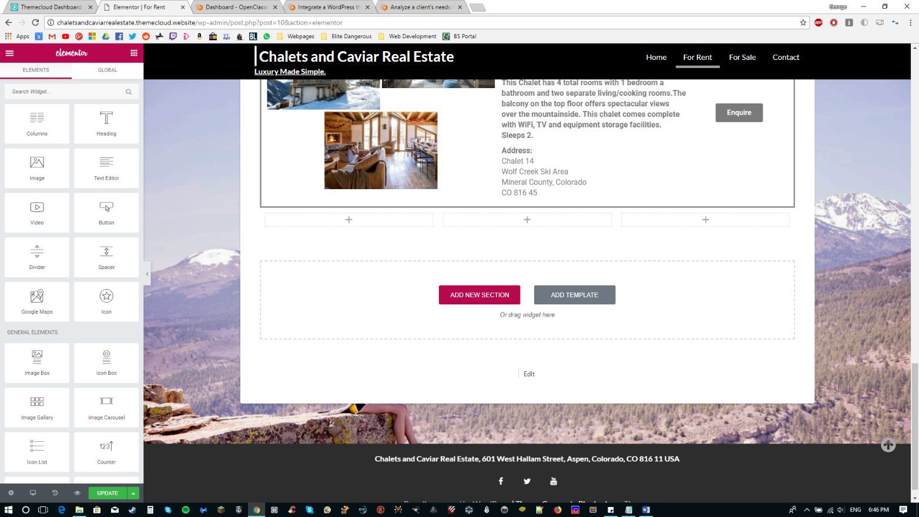

**Section 3 -** Editing the button

You will notice that the button will display as green. Click the button and edit the settings, you can change the text, color and the link in which the button references, it is currently set to go to the contact page, but you are free to decide where the button takes the user.

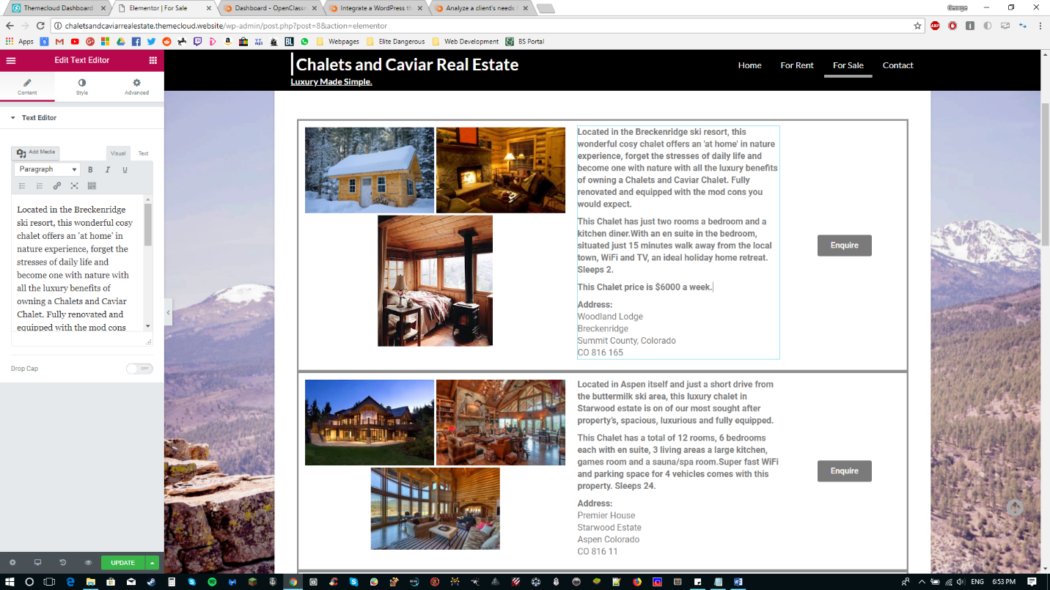**Once you have made all of the desired changes then click the green ‘update’ button at the bottom.**